**SOIL SENSOR SYSTEM**

1**.INTRODUCTION**: Soil monitoring plays a critical role in agriculture as it provides valuable insights into the health and quality of the soil, enabling farmers and agricultural enthusiasts to make informed decisions about crop management. Understanding the soil's characteristics and monitoring its parameters is essential for promoting plant health, maximizing crop productivity, and implementing sustainable farming practices.

Impact on Plant Health: Healthy soil is the foundation for healthy plants. By monitoring soil parameters such as moisture content, pH levels, and temperature, farmers can ensure optimal growing conditions for their crops. Adequate moisture levels prevent under or overwatering, which can lead to plant stress or root rot. Monitoring pH levels helps farmers determine if the soil is acidic or alkaline, allowing them to adjust it to the appropriate range for specific plant types. Furthermore, monitoring soil temperature helps identify conditions that may inhibit or promote plant growth, enabling appropriate measures to be taken.

Crop Productivity: Soil monitoring allows farmers to identify and address nutrient deficiencies or imbalances in the soil. By understanding the nutrient content, farmers can optimize fertilizer application, ensuring that crops receive the necessary nutrients for healthy growth. Additionally, real-time monitoring of soil conditions allows farmers to optimize irrigation practices, preventing water wastage and promoting efficient water usage, thereby enhancing crop productivity.

Sustainable Farming Practices: Efficient soil monitoring promotes sustainable farming practices by reducing resource waste and environmental impact. IoT-based soil monitoring systems provide real-time data, enabling farmers to precisely monitor soil conditions and respond promptly to any deviations. This helps minimize unnecessary use of water, fertilizers, and pesticides, as they can be applied based on actual soil requirements rather than generalized schedules. By adopting precision agriculture techniques facilitated by IoT technology, farmers can reduce their environmental footprint while maintaining or even increasing crop yields.

Revolutionizing Soil Monitoring with IoT Technology: Traditional soil monitoring methods often involve manual sampling and laboratory testing, which can be time-consuming, labor-intensive, and may not provide real-time information. IoT-based soil monitoring systems revolutionize this process by providing real-time data collection, analysis, and insights. With IoT sensors, farmers can remotely monitor soil parameters continuously, allowing for prompt intervention when necessary. The collected data can be transmitted to the cloud for analysis, enabling data-driven decision-making and providing valuable historical trends for future planning.

**2. IoT Soil Monitoring System:**

Our IoT-based soil monitoring system will focus on three crucial soil parameters: moisture level, pH value, and temperature. These parameters are fundamental for plant growth and health, and monitoring them provides valuable insights to optimize crop yield. Let's explore the significance of monitoring these parameters and their effects on crop productivity:

1. Moisture Level:

Monitoring soil moisture is vital as it directly affects plant water uptake and availability. Adequate soil moisture is essential for plant growth, as it enables the transport of nutrients and facilitates various metabolic processes. Insufficient moisture can lead to plant stress, wilting, and reduced crop yield. Conversely, excess moisture can cause root rot and negatively impact plant health. By monitoring soil moisture in real-time, farmers can optimize irrigation schedules, ensuring that plants receive the right amount of water at the right time. This promotes healthy root development, efficient nutrient uptake, and ultimately, higher crop yields.

2. pH Value:

The pH value of the soil measures its acidity or alkalinity and greatly influences nutrient availability to plants. Different plant species thrive within specific pH ranges, and deviations from the optimal range can hinder nutrient absorption. Monitoring the soil pH level allows farmers to adjust and maintain the pH within the appropriate range for the targeted crops. Acidic soils (low pH) can result in nutrient deficiencies, while alkaline soils (high pH) can lead to nutrient imbalances. By ensuring the soil pH is suitable for the crops being cultivated, farmers can enhance nutrient availability, promote proper plant growth, and maximize crop productivity.

3. Temperature:

Soil temperature plays a crucial role in plant growth and development. It influences seed germination, root development, nutrient uptake, and overall plant metabolism. Different crops have specific temperature requirements for optimal growth. Monitoring soil temperature helps farmers identify potential issues such as excessively cold or hot conditions that can impede plant growth. It also helps in making informed decisions regarding planting times, optimizing crop rotation, and implementing appropriate measures for climate control. By maintaining optimal soil temperature conditions, farmers can improve crop yield and overall plant health.

Effects on Crop Yield:

Monitoring soil moisture, pH value, and temperature and optimizing them based on crop requirements have significant effects on crop yield:

1. Enhanced Nutrient Uptake: By monitoring and managing soil moisture and pH levels, plants can efficiently absorb essential nutrients. This promotes healthy plant growth, improves nutrient utilization, and increases crop yield.

2. Disease Prevention: Monitoring soil moisture and temperature can help prevent the development of plant diseases caused by excessive moisture or favorable conditions for pathogens. Maintaining appropriate soil moisture levels and temperature reduces the risk of plant infections and subsequent yield losses.

3. Efficient Resource Management: Real-time monitoring of soil parameters allows farmers to optimize irrigation practices, conserve water resources, and minimize fertilizer usage. This leads to cost savings and reduces environmental impact while still maintaining or improving crop productivity.

4. Timely Intervention: Monitoring soil parameters in real-time enables farmers to identify deviations or abnormalities promptly. This allows for timely intervention, such as adjusting irrigation schedules, pH levels, or implementing climate control measures, to mitigate potential crop stress and yield losses.

In conclusion, an IoT-based soil monitoring system incorporating moisture level, pH value, and temperature provides valuable insights for optimizing crop yield. Monitoring these parameters ensures proper water availability, nutrient absorption, disease prevention, and resource management. By leveraging IoT technology, farmers can make data-driven decisions and implement timely interventions to maximize crop productivity and overall farm sustainability.

**3.Tinkercad Simulation::**

1. Data Collection:

Data collection in the simulation code occurs through the analogRead() function, which reads the sensor values from the temperature and moisture sensors connected to the Arduino. The analog readings are then stored in variables (sensor and soilsensor) for further processing.

2. Data Processing and Analysis:

In the simulation code, the data processing and analysis are minimal. The voltage and Celsius values are calculated based on the analog readings from the temperature sensor. However, in a complete IoT-based soil monitoring system, additional processing and analysis can be performed on the collected data. This can include statistical calculations, data filtering, or applying algorithms to derive insights and patterns from the sensor data.

3. Data Transmission:

The provided simulation code does not include data transmission functionality. In an actual IoT-based soil monitoring system**,** the collected and processed data would be transmitted to a remote server or cloud platform. This is typically done using wireless communication protocols such as Wi-Fi, cellular networks, or IoT-specific protocols like MQTT or HTTP. The data can be packaged into messages and sent over the network to a designated endpoint for further processing and storage.

4. Data Storage:

Similarly, the simulation code does not include data storage functionality. In a real IoT-based soil monitoring system, the transmitted data would be received by a server or cloud platform and stored in databases or data storage systems. Time-series databases or relational databases are commonly used to store sensor data. The data can be organized, indexed, and archived for historical analysis, visualization, and retrieval.It's important to note that while the provided simulation code does not include the actual implementation of data transmission and storage, these processes are crucial in an IoT-based soil monitoring system. Implementing data transmission and storage capabilities allows for remote monitoring, centralized data analysis, historical trend analysis, and enables the integration of advanced analytics and visualization tools to gain valuable insights for efficient farming practices.

**LINK OF SIMULATION**

: 1.https://www.tinkercad.com/things/c7Vk114wFNe-soil-monitoring-system/editel?sharecode=mKM3rjXd046_zpnnVLvYeT6jzukrin7Il9u0fBUXBrA

2. <https://www.tinkercad.com/things/c7Vk114wFNe-soil-monitoring-system/editel?sharecode=mKM3rjXd046_zpnnVLvYeT6jzukrin7Il9u0fBUXBrA>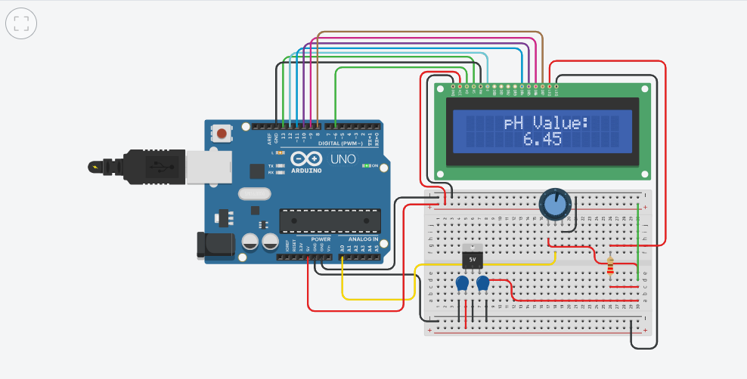

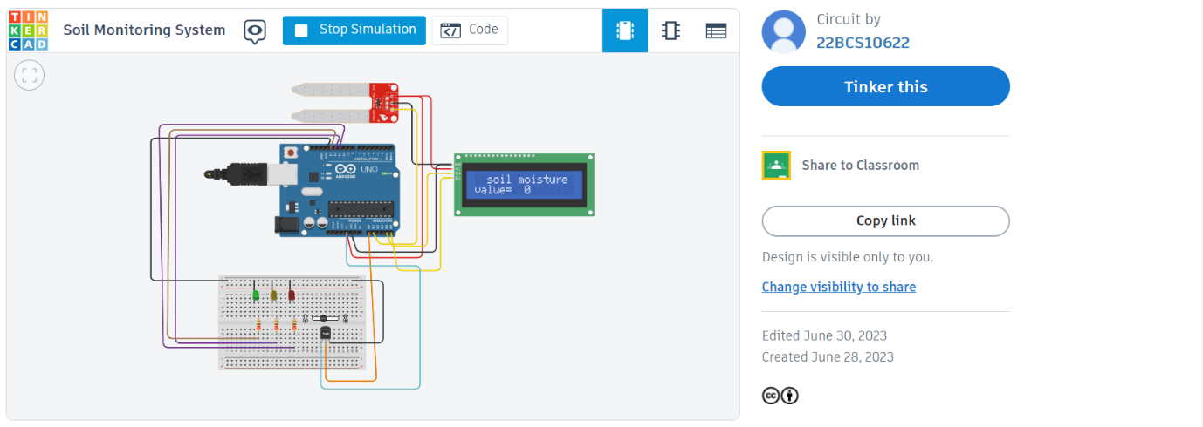

**4. Benefits and Applications:**

1. Optimization of Irrigation Practices:

The IoT soil monitoring system offers real-time data on soil moisture levels, enabling farmers to optimize irrigation practices. By monitoring soil moisture, farmers can ensure that plants receive the right amount of water at the right time. This prevents under- or over-irrigation, leading to improved water efficiency, reduced water waste, and enhanced crop productivity. For example, the WaterBit IoT-based irrigation system implemented by California-based Bowles Farming Company reduced water usage by 20% and increased crop yield by 20% in their tomato fields.2. Prevention of Over-Fertilization:

With IoT soil monitoring, farmers can precisely monitor soil nutrient levels and avoid over-fertilization. Excessive fertilizer application can lead to nutrient runoff, environmental pollution, and decreased crop quality. By continuously monitoring soil parameters like pH and nutrient levels, farmers can adjust their fertilizer application rates and ensure optimal nutrient availability for plant growth. The SmartFarm IoT solution deployed in strawberry fields by PlantTape, an agricultural technology company, helped reduce fertilizer usage by 20% while increasing yield and fruit quality.

3. Detection of Soil Imbalances:

The IoT soil monitoring system enables the detection of soil imbalances, such as pH deviations or nutrient deficiencies, which can negatively impact crop health. By continuously monitoring and analyzing soil parameters, farmers can identify imbalances early on and take corrective measures. For instance, CropX, an Israeli-based company, deployed their IoT soil monitoring technology in vineyards, helping farmers detect soil variations across different plots. By adjusting irrigation and nutrient application based on the specific soil needs of each plot, they achieved a 30% reduction in water usage and increased grape quality.

4. Efficient Resource Management:The IoT soil monitoring system facilitates efficient resource management by providing real-time data on soil conditions. This data helps farmers make informed decisions regarding water and fertilizer usage, leading to optimized resource allocation and reduced environmental impact. A case study conducted by the University of California Cooperative Extension found that the use of soil moisture sensors in almond orchards resulted in water savings of 33% while maintaining or increasing crop yields.

5. Sustainable Farming Practices:

By enabling precise monitoring and management of soil parameters, the IoT soil monitoring system promotes sustainable farming practices. It helps farmers minimize input waste, reduce environmental impact, and improve overall farm sustainability. A study conducted in tomato cultivation by the University of Florida showed that utilizing soil moisture sensors resulted in a 40% reduction in water use and a 14% increase in crop yield.

In summary, the IoT soil monitoring system offers numerous benefits and applications in agriculture. It optimizes irrigation practices, prevents over-fertilization, detects soil imbalances, and promotes efficient resource management. Real-life examples and case studies demonstrate the positive impact of IoT soil monitoring systems in improving water efficiency, reducing fertilizer usage, enhancing crop quality, and supporting sustainable farming practices.

**5. Sustainability and Environmental Impact:** The IoT soil monitoring system plays a crucial role in promoting sustainable farming practices and reducing the environmental impact of agricultural operations. Here's how precise monitoring and targeted interventions facilitated by the system can minimize the use of water, fertilizers, and pesticides, leading to improved soil health:

1. Water Conservation:- Real-time monitoring of soil moisture levels allows farmers to optimize irrigation practices by providing them with accurate information on when and how much water is needed by the plants. This eliminates guesswork and prevents over-irrigation, which can lead to water wastage and waterlogging.- By avoiding under-irrigation, the IoT soil monitoring system ensures that plants receive sufficient water for healthy growth, preventing water stress and yield losses.- Optimal irrigation practices driven by the IoT soil monitoring system reduce water consumption, conserve water resources, and contribute to overall water sustainability in agriculture.

2. Precision Nutrient Management:- The IoT soil monitoring system provides insights into soil nutrient levels, pH, and other important parameters. This information allows farmers to precisely manage fertilizer application, avoiding over-fertilization.- By applying fertilizers in the right amount and at the right time, farmers can prevent nutrient leaching, minimizing the negative impact on water bodies and reducing the risk of environmental pollution.- Targeted nutrient management based on real-time soil data promotes efficient nutrient uptake by plants, leading to improved crop health and reduced dependence on excessive fertilizer use.

3. Reduced Pesticide Usage:- The IoT soil monitoring system enables early detection of soil imbalances, nutrient deficiencies, or pest infestations. This timely information allows farmers to implement targeted interventions, such as integrated pest management (IPM) strategies.- By precisely identifying pest hotspots or specific areas requiring treatment, farmers can reduce the overall use of pesticides. This targeted approach minimizes the environmental impact of pesticide applications and preserves beneficial insects and organisms.- The IoT soil monitoring system also helps farmers monitor soil health indicators, such as organic matter content and microbial activity, which can indirectly contribute to pest and disease management. A healthy soil ecosystem reduces the vulnerability of crops to pests and diseases, reducing the need for chemical interventions.

4. Soil Health Improvement:- Continuous monitoring of soil parameters and targeted interventions based on real-time data contribute to the overall improvement of soil health.- By optimizing irrigation, nutrient management, and pesticide applications, the IoT soil monitoring system helps maintain a balanced soil ecosystem, promoting beneficial microbial activity and enhancing nutrient cycling.- Improved soil health leads to increased soil fertility, enhanced water-holding capacity, and better overall plant growth and productivity. Healthy soils are more resilient to environmental stresses and require fewer external inputs.

In summary, the IoT soil monitoring system promotes sustainable farming practices by enabling precise monitoring and targeted interventions. Through optimized water usage, precise nutrient management, reduced pesticide application, and soil health improvement, the system contributes to reduced environmental impact, enhanced resource efficiency, and improved soil health in agricultural operations.

**6.Conclusion:**

The IoT soil monitoring system offers a range of key features and benefits that can revolutionize agriculture and contribute to sustainable farming practices. By incorporating IoT technology and real-time data analysis, this system provides farmers and stakeholders with valuable insights to optimize their agricultural practices.

Key Features and Benefits:

1. Real-time Monitoring: The IoT soil monitoring system provides real-time data on soil parameters such as moisture level, pH value, and temperature. This enables farmers to make informed decisions and take timely actions to ensure optimal growing conditions for their crops.

2. Precise Resource Management: With accurate and up-to-date information on soil conditions, farmers can optimize their irrigation practices, reduce water waste, and conserve this precious resource. The system also aids in targeted nutrient management, minimizing fertilizer usage and reducing the risk of environmental pollution.

3. Enhanced Crop Health and Yield: By monitoring soil parameters and detecting imbalances early on, the IoT system helps prevent crop stress, nutrient deficiencies, and pest infestations. This promotes healthier plants, higher crop yields, and improved overall farm productivity.

4. Sustainable Practices: The IoT soil monitoring system supports sustainable farming practices by reducing the environmental impact of agriculture. By minimizing water usage, fertilizer application, and pesticide usage, farmers can preserve natural resources, minimize pollution, and promote ecological balance.

5. Cost Savings: By optimizing resource management and reducing input wastage, the IoT soil monitoring system can lead to cost savings for farmers. Precise irrigation and nutrient management can result in lower water and fertilizer expenses, while targeted pest control measures reduce the need for excessive pesticide applications.

Call to Action:

Embracing IoT technology for sustainable agriculture is essential for the future of farming. By implementing an IoT soil monitoring system, farmers and stakeholders can gain access to critical insights and tools that optimize resource management, enhance crop health, and reduce the environmental impact of their operations.

Let us seize the opportunity to leverage IoT technology and real-time data analysis to transform the way we monitor and manage our soils. By adopting IoT soil monitoring systems, we can achieve sustainable and efficient agricultural practices that ensure the long-term viability of our farms while safeguarding our environment.

Together, let us embrace IoT technology and work towards a future of sustainable agriculture, where we maximize productivity, conserve resources, and promote ecological balance.